St Paul’s shares and promotes the Vision for Religious Education articulated by Brisbane Catholic Education and the wider church.
St Paul’s School, along with all other schools in the Archdiocese of Brisbane, works from the model of Religious Education that encompasses two dimensions-
the classroom teaching of religion using the Religious Education Curriculum and
teaching students to be religious, drawing upon the Catholic Christian tradition
At St Paul’s School, Woodridge, we do this in a way that is mindful of contemporary social challenges and the multi-faith community in which we are situated.
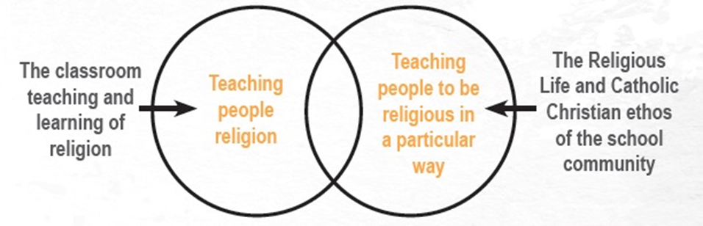

This vision shares the goal for learning and teaching as expressed in Brisbane Catholic Education Learning and Teaching Framework (2012):
As a Catholic Christian community, we educate all to live the gospel of Jesus Christ as successful, creative and confident, active and informed learners empowered to shape and enrich our world.

